# DES 5.0 Standard Testcase’s Automation Pre-requisites

DES 5.0 Standard project is created with the Cucumber Framework with page Object Model integrating with Maven Build Tool and TestNG runner for the extends report. Below is the folder structure of the DES Standard Framework.

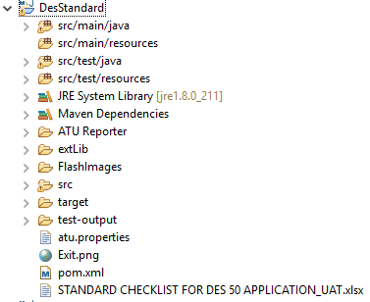

Steps to be followed before executing the Scenario’s

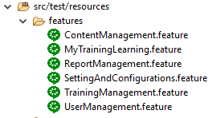

Features File contains the Scenario Steps in a plain English text and maps with the Step definition which describe the selenium and java code to drive the test steps.

### Changes Required in the ContentManagement Feature File - 4 Scenarios

1. Validate HTML5 course customease can be done successfully by previewing the course

* Change the **URL, UserID, Password, CurriculumName and CourseName** as per the requirement in the Examples to parametrize the test data.
* The provided CurriculumName and CouseName should be available in the database as prerequisites

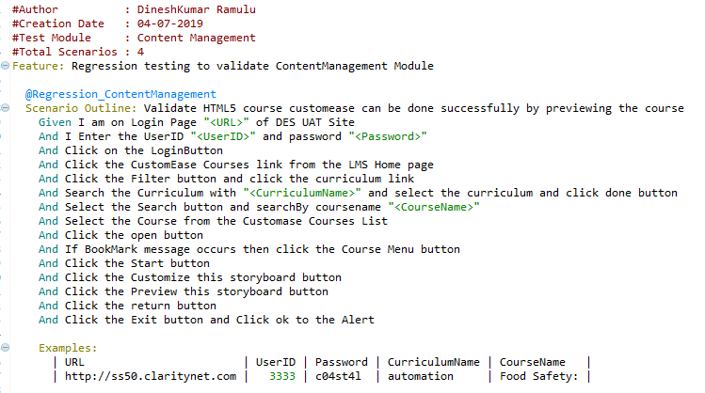

1. Validate ML course customease can be done successfully by previewing the course

* Change the **URL, UserID, Password, CurriculumName and CourseName** as per the requirement in the Examples to parametrize the test data.
* The provided CurriculumName and CouseName should be available in the database as prerequisites

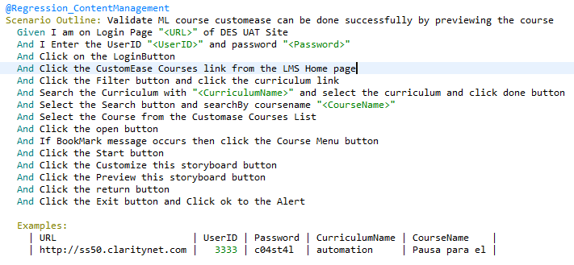

1. Validate the course can be published successfully in the HTML5 Authoring Tool

* Change the **URL, UserID, Password and CourseName** as per the requirement in the Examples to parametrize the test data.
* The provided CouseName should be available in the database as prerequisites

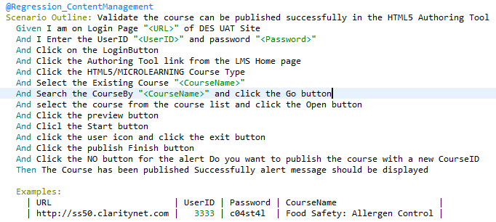

1. Validate the course can be Imported successfully in the HTML5 Authoring Tool

* Change the **URL, UserID, Password and CourseName** as per the requirement in the Examples to parametrize the test data.
* The provided CouseName should be available in the database as prerequisites

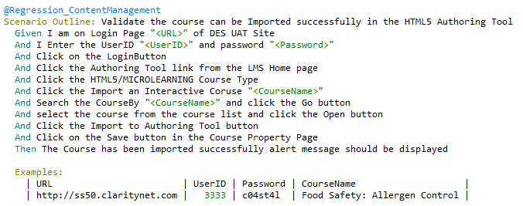

* Changes Required in the MyTrainingLearning Feature File

- 10 Scenarios

1. Validate HTML5 Additional Learning Course Launch Successful

* Change the **URL, UserID, Password , CourseName** **and CourseTitle** as per the requirement in the Examples to parametrize the test data.
* The provided CouseName and CourseTitle should be available in the database as prerequisites

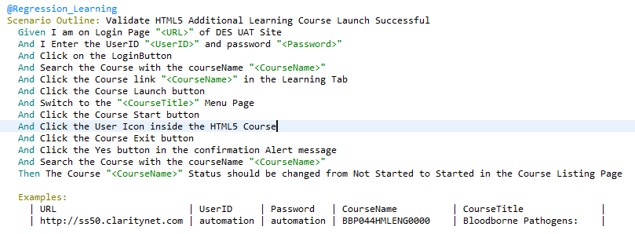

1. Validate ML Additional Learning Course Launch Successful

* Change the **URL, UserID, Password , CourseName** **and CourseTitle** as per the requirement in the Examples to parametrize the test data.
* The provided CouseName and CourseTitle should be available in the database as prerequisites

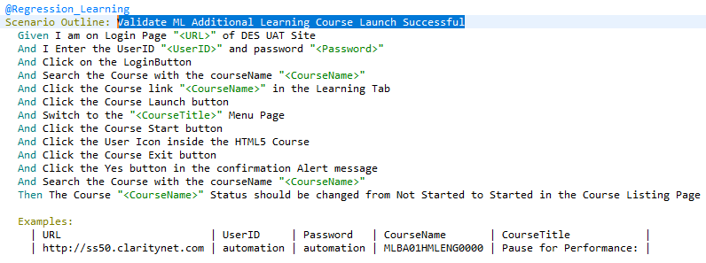

1. Validate HTML5 Curriculum Course Launch Successful

* Change the **URL, UserID, Password , CourseName** **and CourseTitle** as per the requirement in the Examples to parametrize the test data.
* The provided CouseName and CourseTitle should be available in the database as prerequisites

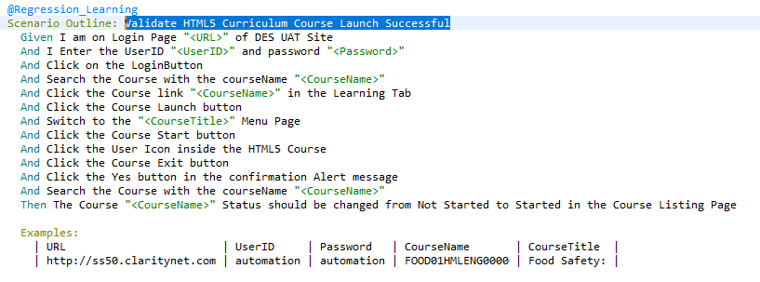

1. Validate ML Curriculum Course Launch Successful

* Change the **URL, UserID, Password , CourseName** **and CourseTitle** as per the requirement in the Examples to parametrize the test data.
* The provided CouseName and CourseTitle should be available in the database as prerequisites

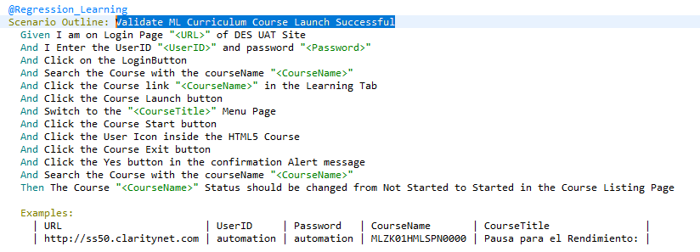

1. Validate HTML5 Remote Course Launch Successful for the HTTP Site with Preview Mode Zero

* Change the **Remote Launch** **URL, and CourseTitle** as per the requirement in the Examples to parametrize the test data.
* The provided CourseTitle should be available in the database and Remote Launch URL should be valid as prerequisites

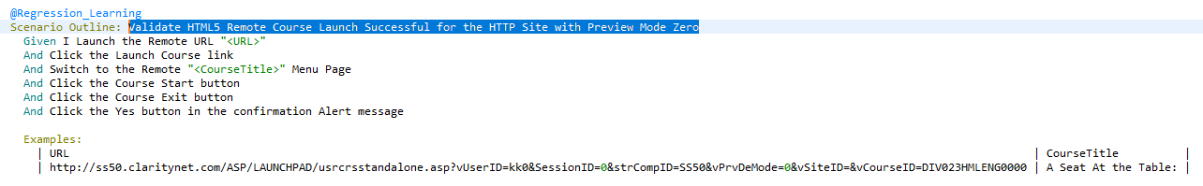

1. Validate ML Remote Course Launch Successful for the HTTP Site with Preview Mode Zero

* Change the **Remote Launch** **URL, and CourseTitle** as per the requirement in the Examples to parametrize the test data.
* The provided CourseTitle should be available in the database and Remote Launch URL should be valid as prerequisites

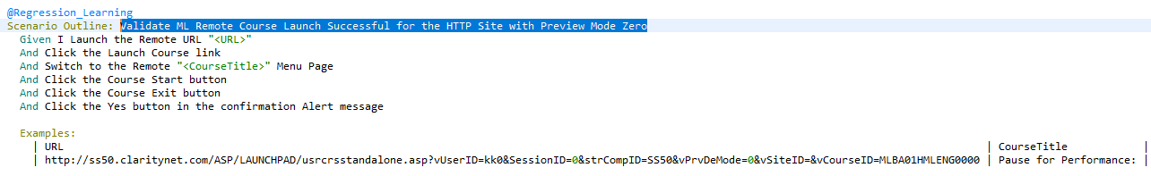

1. Validate HTML5 Remote Course Launch Successful for the HTTP Site with Preview Mode One

* Change the **Remote Launch** **URL, and CourseTitle** as per the requirement in the Examples to parametrize the test data.
* The provided CourseTitle should be available in the database and Remote Launch URL should be valid as prerequisites

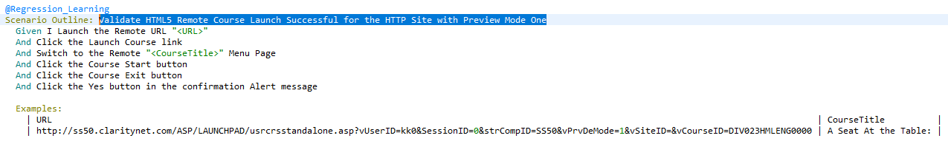

1. Validate HTML5 Remote Course Launch Successful for the HTTPS Site with Preview Mode Zero

* Change the **Remote Launch** **URL, and CourseTitle** as per the requirement in the Examples to parametrize the test data.
* The provided CourseTitle should be available in the database and Remote Launch URL should be valid as prerequisites

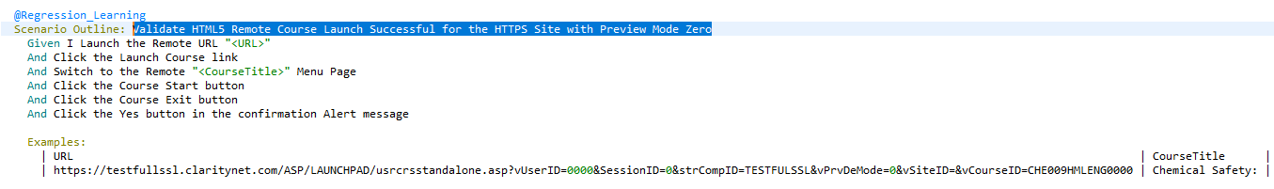

1. Validate ML Remote Course Launch Successful for the HTTPS Site with Preview Mode Zero

* Change the **Remote Launch** **URL, and CourseTitle** as per the requirement in the Examples to parametrize the test data.
* The provided CourseTitle should be available in the database and Remote Launch URL should be valid as prerequisites

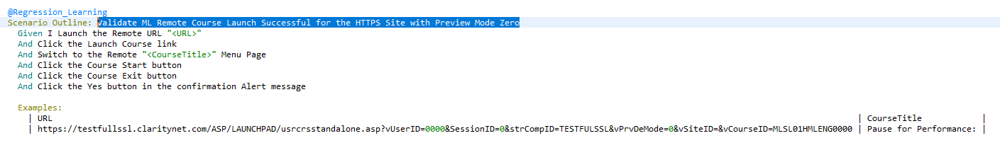

1. Validate HTML5 Remote Course Launch Successful for the HTTPS Site with Preview Mode One

* Change the **Remote Launch** **URL, and CourseTitle** as per the requirement in the Examples to parametrize the test data.
* The provided CourseTitle should be available in the database and Remote Launch URL should be valid as prerequisites

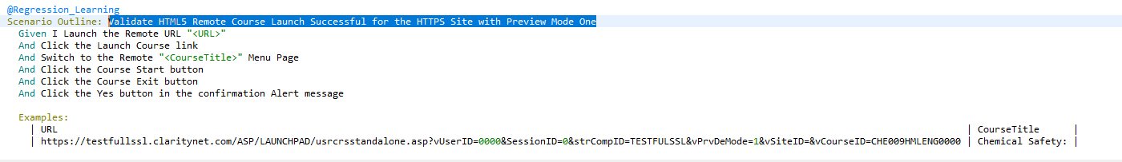

* Changes Required in the ReportManagement Feature File

- 9 Scenarios

1. Validate User Planned Vs Completed Report Process Success

* Change the **URL, UserID, Password and** **ReportName** as per the requirement in the Examples to parametrize the test data.
* The provided ReportName should be available in the database as prerequisites

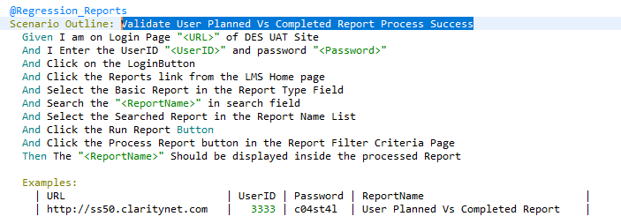

1. Validate My Training Status Report Process Success

* Change the **URL, UserID, Password and** **ReportName** as per the requirement in the Examples to parametrize the test data.
* The provided ReportName should be available in the database as prerequisites

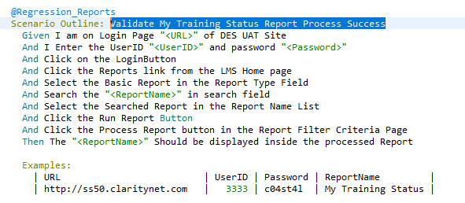

1. Validate User Training Status - Enhanced Report Process Success

* Change the **URL, UserID, Password and** **ReportName** as per the requirement in the Examples to parametrize the test data.
* The provided ReportName should be available in the database as prerequisites

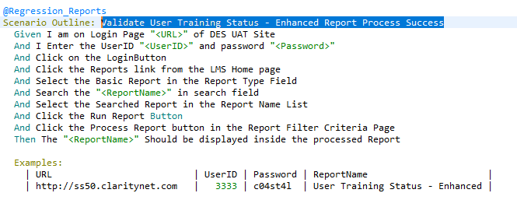

1. Validate My Test Scores Report Process Success

* Change the **URL, UserID, Password and** **ReportName** as per the requirement in the Examples to parametrize the test data.
* The provided ReportName should be available in the database as prerequisites

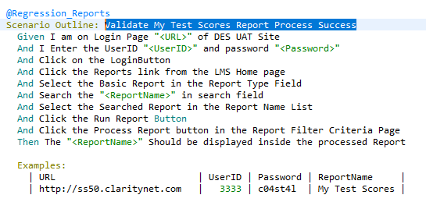

1. Validate My Test Scores - Enhanced Report Process Success

* Change the **URL, UserID, Password and** **ReportName** as per the requirement in the Examples to parametrize the test data.
* The provided ReportName should be available in the database as prerequisites

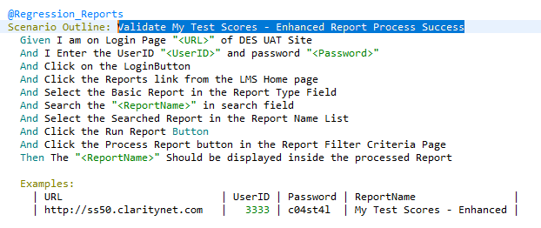

1. Validate User Planned Vs Completed Custom Report Create and Process Success

* Change the **URL, UserID, Password, ReportName, Report Title and CustomReportName** as per the requirement in the Examples to parametrize the test data.
* The provided ReportName should be available in the database and the Custom Report Title should be new title and the Report Title and the CustomReportName should be same name as prerequisites

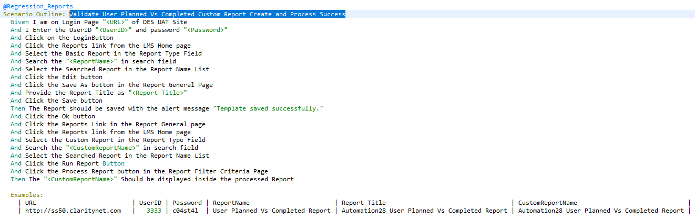

1. Validate Unformatted User Planned Vs Completed Report Process Success

* Change the **URL, UserID, Password and** **ReportName** as per the requirement in the Examples to parametrize the test data.
* The provided ReportName should be available in the database as prerequisites

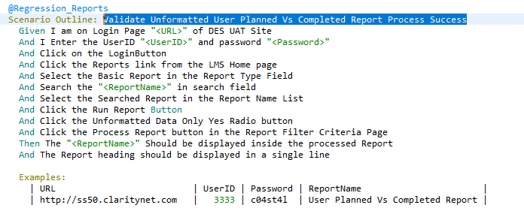

1. Validate DB User Course Status Chart Report Process Success

* Change the **URL, UserID, Password and** **ReportName** as per the requirement in the Examples to parametrize the test data.
* The provided ReportName should be available in the database as prerequisites

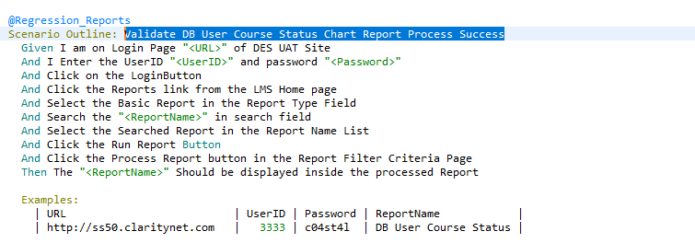

1. Validate User Planned Vs Completed Report Process Success and records exported to xls,pdf,xlsx,cvs

* Change the **URL, UserID, Password, ReportName** and **DownloadPath** as per the requirement in the Examples to parametrize the test data.
* The provided ReportName should be available in the database and Downloadpath should be valid as prerequisites

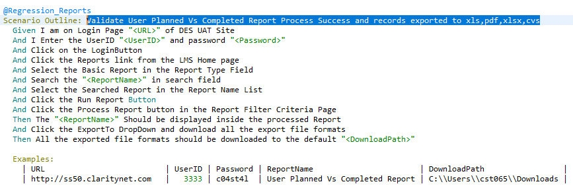

* Changes Required in the SettingAndConfigurations Feature File

- 1 Scenarios

1. Validate Global Options Edit and Save Success

* Change the **URL, UserID, Password and** **LogoutTime** as per the requirement in the Examples to parametrize the test data.

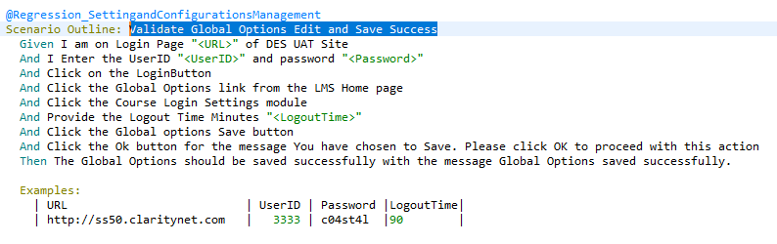

* Changes Required in the TrainingManagementFeature File

- 4 Scenarios

1. Validate Curriculum create and assign course and user Success

* Change the **URL, UserID, Password, CurriculumName, CurriculumID, CourseID and UserID** as per the requirement in the Examples to parametrize the test data.
* The provided CurriculumName and CurriculumID shouldn’t be already existed and CourseID and UserID should be available in the database as prerequisites

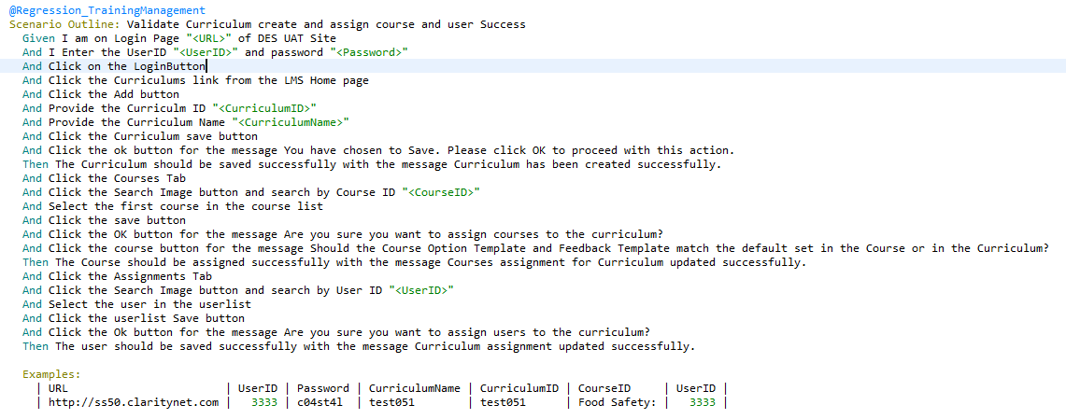

1. Validate Edit Course and assign user to that course

* Change the **URL, UserID, Password, CourseName and UserID** as per the requirement in the Examples to parametrize the test data.
* The provided CourseID and UserID should be available in the database as prerequisites.

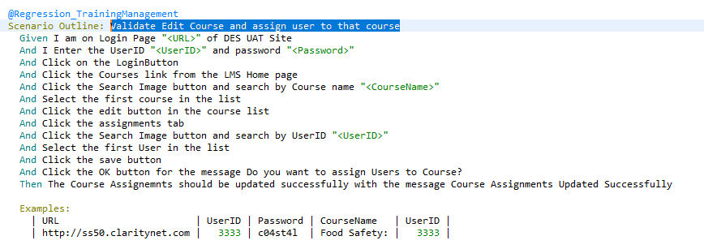

1. Validate Edit Course Options template and course options template Update success

* Change the **URL, UserID, Password, CourseName and TemplateName** as per the requirement in the Examples to parametrize the test data.
* The provided TemplateName shouldn’t be available in the database as prerequisites.

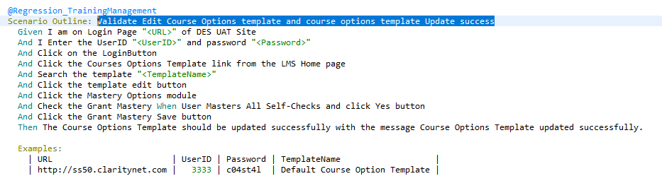

1. Validate Classroom handson update success

* Change the **URL, UserID, Password, CourseName, UserID and CourseStatus** as per the requirement in the Examples to parametrize the test data.
* The provided CourseName and UserID should be available in the database as prerequisites.

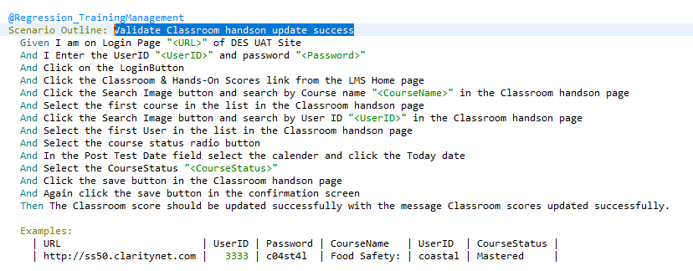

* Changes Required in the UserManagement File

- 6 Scenarios

1. Validate Add User

* Change the **URL, UserID, Password, NewUserID, LastName, FirstName, EmailID, ConfirmEmailID, Password, confrimpassword, RoleName** as per the requirement in the Examples to parametrize the test data.
* The provided NewUserID shouldn’t be available in the database as prerequisites.

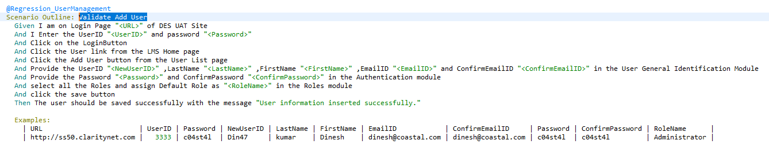

1. Validate Existing User by update and save

* Change the **URL, UserID, Password, SearchUserID, and language** as per the requirement in the Examples to parametrize the test data.
* The provided SearchUserID and language should be available in the database as prerequisites.

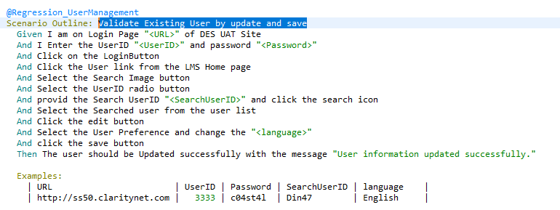

1. Validate Add NewGroup

* Change the **URL, UserID, Password and Groupvalue** as per the requirement in the Examples to parametrize the test data.
* The provided Groupvalue shouldn’t be available in the database as prerequisites.

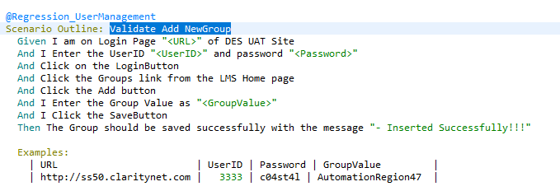

1. Validate Add NewRole

* Change the **URL, UserID, Password and RoleName** as per the requirement in the Examples to parametrize the test data.
* The provided RoleName shouldn’t be available in the database as prerequisites.

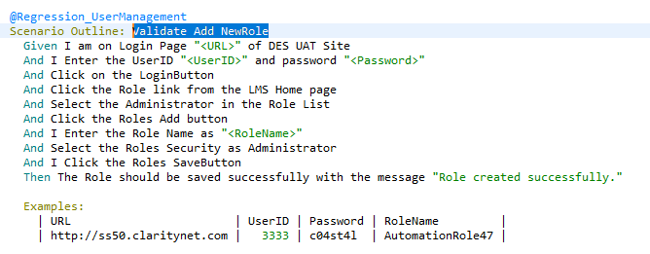

1. Validate Existing User by Navigating multiple tabs and Update and Save

* Change the **URL, UserID, Password, SearchUserID and SearchRegionValue** as per the requirement in the Examples to parametrize the test data.
* The provided SearchuserID and SearchRegionValue should be available in the database as prerequisites.

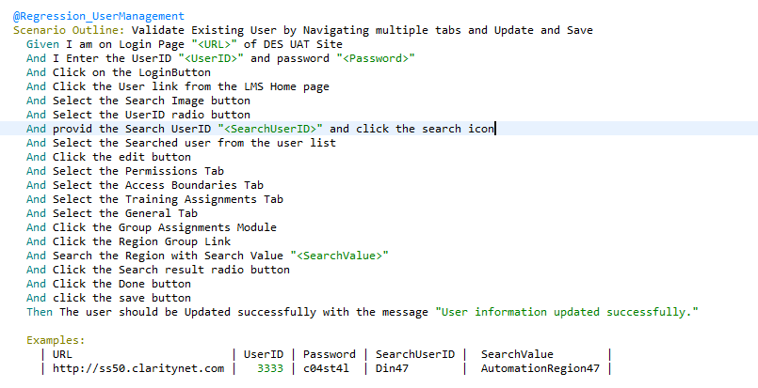

1. Validate Add New Custom Tab

* Change the **URL, UserID, Password, TabName and ContentText** as per the requirement in the Examples to parametrize the test data.
* The provided TabName shouldn’t be available in the database as prerequisites.

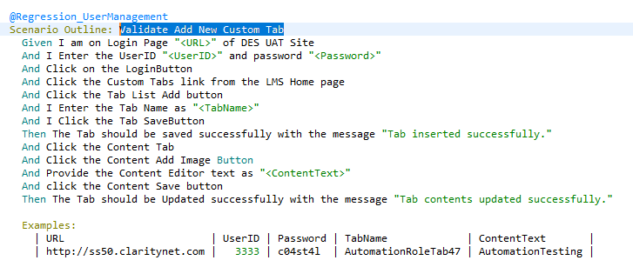

End of Features File Scenarios

**Following Steps to be followed to execute the Test Scenarios**

1. Navigate to RunCuke.java Class
2. Replace the tags name where highlighted with the yellow color. Each Scenario is associated with the tag name in the feature files. So the provided tag name scenarios in the runcuke alone will be executed.

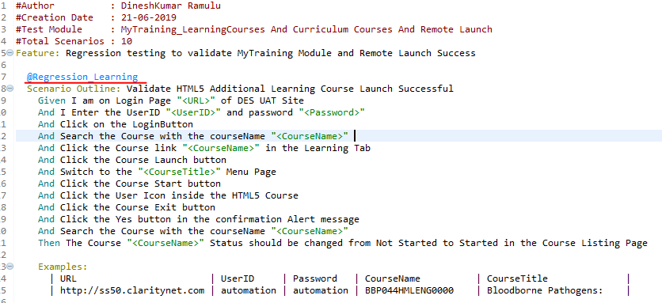

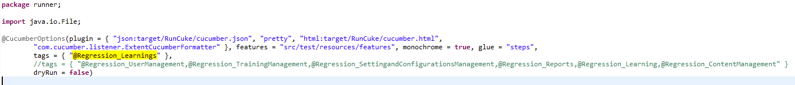

1. Suppose if you would like to execute multiple scenarios which also available in an another feature files. Then just provide the tag names followed by a punctuation mark (,) as below examples
2. 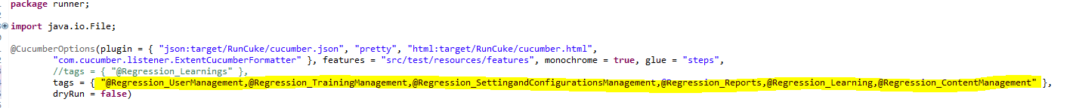In the RunCuke.java file replace the Browser Name, Browser Version, Selenium Version which highlighted in the yellow color below. The provided details will be displayed in the reports after the test run.

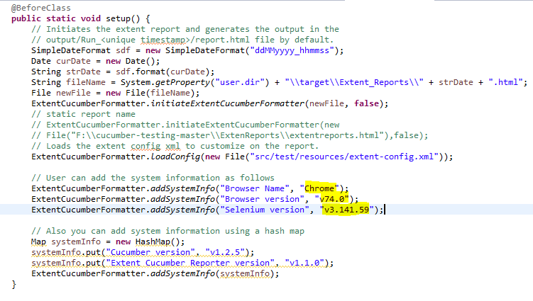

1. Navigate to SeleniumDriver.java class and change the browser name to which browser do you want to execute inside the LaunchBrowser function highlighted in yellow ( e.g) LaunchBrowser("chrome") , LaunchBrowser("IE") , LaunchBrowser("firefox") .

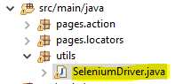

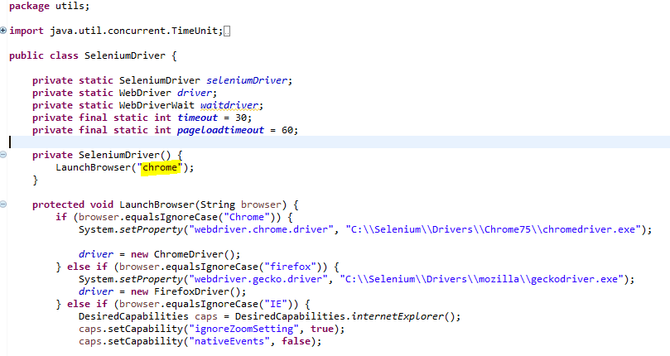

1. To Run the test , right click the testing.xml and click Run As TestNG Suite. Then it will launch the browser and start execute the code.

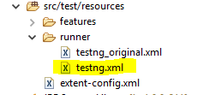

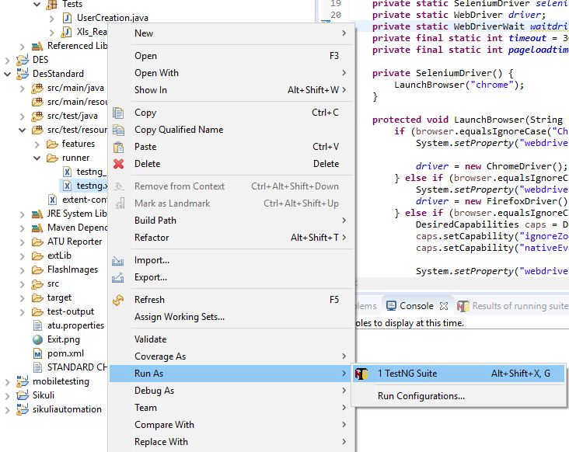

1. Once the test is finish executing, right click the DesStandard folder and click the Refresh.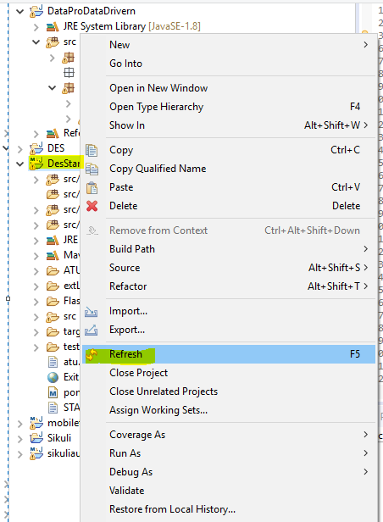
2. In the target-🡪 Extent_Reports folder, the html file will be generated based on the timestamp we executed.

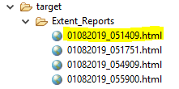

1. When we click the html report file, we can see the detail extent reports for the test execution. You can copy the link and paste it in browser to view the report in full screen.

